

EEE 4706

Project Report

**Bluetooth Interfacing with 8051 Microcontroller**

**Bluetooth Interfacing with 8051 Microcontroller**

Introduction 3

Objectives 3

Required Components 4

Schematic Circuit 4

Our chosen Bluetooth Module: HC 05 5

Pinout of the Project 7

Control Panel 8

LCD Initialisation 9

Demonstration 11

Counter 12

Morse Code Mode 13

LED Matrix 15

Working Procedure 15

Demonstration 19

Encryption 20

Demonstration 22

LED Relay Control 23

EXIT Mode 24

Problems Faced 25

Final Discussion 25

Complete Code 26

# Introduction

The objective of this project was to combine Bluetooth technology with the 8051 microprocessor. The objective was to facilitate different operations that were activated by certain characters sent via a Serial Bluetooth Android application. These characters enabled several functions, including initiating countdowns, controlling relays and buzzers, transmitting Morse code, and implementing encryption. The report provides an extensive documentation that outlines the practical aspects, features, and importance of incorporating Bluetooth technology into the 8051 microcontroller in order to facilitate a wide range of real-time programmes.

# Objectives

1. **Receive Data:** 8051 Microcontroller to receive data from the HC 05 Bluetooth module.
2. **Check for Specific Characters:** Once data is received, the uC needs to check for specific special characters (C, L, y, n, 1, M, X, D, 0).
3. **Execute Corresponding Actions:** Implementation functions or logic to perform the desired actions based on the received characters. For example:
4. For 'C': Countdown and buzzer ringing with LCD display updates.
5. For uppercase 'L' and lowercase 'L': Controlling the LED relay accordingly.
6. For 'y' and 'n': Activate or deactivate the buzzer.
7. For '1': Toggle the LED relay based on subsequent numbers received.
8. For 'M': Activate the Morse code mode.
9. For 'X': Switch to the 8x8 LED Matrix mode.
10. For 'D': Implement the encryption mode for the messages.

4. **Exit Modes:** When '0' is received, reset the system to its initial state.

# Required Components

|  |  |
| --- | --- |
| Name | Price (BDT) |
| 8051 Development Board | 7000 |
| Bluetooth HC-05 | 350 |
| **Total** | **7350** |

# Schematic Circuit

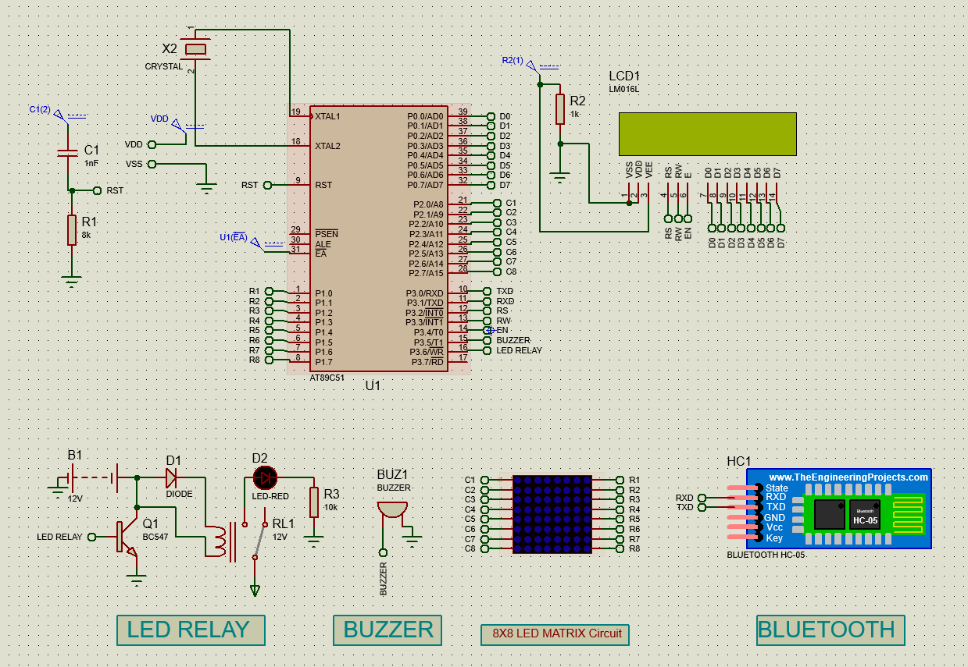

# Our chosen Bluetooth Module: HC 05

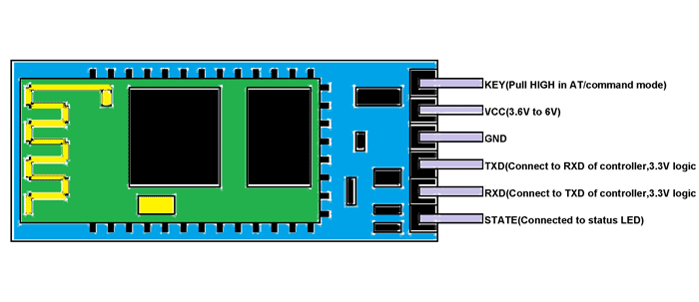**HM-06** is a **Bluetooth module** designed for establishing short range wireless data communication between two microcontrollers or systems. The module works on **Bluetooth 2.0 communication protocol** and it can only act as a slave device. This is cheapest method for wireless data transmission and more flexible compared to other methods and it even can transmit files at speed up to 2.1Mb/s.

Figure 1. HC 05 Bluetooth Module

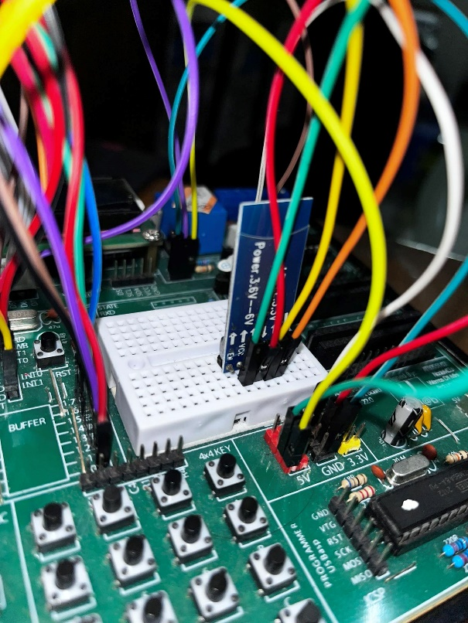HC-06 uses frequency hopping spread spectrum technique (**FHSS**) to avoid interference with other devices and to have full duplex transmission. The device works on the frequency range from 2.402 GHz to 2.480GHz.

Figure 2. HC05 Hardware Implementation

**Code**

; for Bluetooth module

MOV TMOD,#20H ; timer 1 mode 2 is selected

MOV TH1,#0FDH ; baud rate

MOV SCON,#50H ; serial mode 1 10 bit total isn, 8db, 1STOPb

CLR TI ; making TI reg zero

SETB TR1 ; starting timer 1

# Pinout of the Project

|  |  |
| --- | --- |
| P0.0 | LCD |
| P0.1 |
| P0.2 |
| P0.3 |
| P0.4 |
| P0.5 |
| P0.6 |
| P0.7 |
| P1.0 | R1 |
| P1.1 | R2 |
| P1.2 | R3 |
| P1.3 | R4 |
| P1.4 | R5 |
| P1.5 | R6 |
| P1.6 | R7 |
| P1.7 | R8 |
| P2.0 | C1 |
| P2.1 | C2 |
| P2.2 | C3 |
| P2.3 | C4 |
| P2.4 | C5 |
| P2.5 | C6 |
| P2.6 | C7 |
| P2.7 | C8 |
| P3.0 | TXD |
| P3.1 | RXD |
| P3.2 | RS |
| P3.3 | RW |
| P3.4 | EN |
| P3.5 | BUZZER |
| P3.6 | LED |
| P3.7 | N/A |

# Control Panel

|  |  |  |  |
| --- | --- | --- | --- |
| **Sl No.** | **Character** | **Mode Name** | **Description** |
| 1 | C | Counter | The system initiates a countdown from 9 to 1, subsequently activating a buzzer on the 10th second for a specified duration. Simultaneously, the countdown was displayed on an LCD screen |
| 2 | Uppercase L | LED ON | Turns LED Relay ON |
| 3 | Lowercase L | LED OFF | Turns LED Relay OFF |
| 4 | y | Buzzer ON | Turns Buzzer ON |
| 5 | n | Buzzer OFF | Turns Buzzer OFF |
| 6 | M | Morse Code | Sends Messages in Morse Code of either A or B. |
| 7 | X | LED Matrix | Activates 8x8 LED Matrix of the 8051 Development Board and has the ability to display either A, B or C. |
| 8 | D | Encryption | Triggers Encryption Mode where messages were replaced with predetermined encrypted message formats |
| 9 | 1 (One) | Relay Control | Toggle LED relay based on subsequent numbers received |
| 10 | 0 (Zero) | Mode OFF | Upon sending, turns of any of the above activated modes and reverts back to the original state when the 8051 was turned ON. |

# LCD Initialisation

The following is a snippet of the LCD initialization part of the entire code. We used DPTR look tables to access the values for COMWRT to be set for LCD. And subsequently, we added a small message to begin the project demonstration.

**Code**

ORG 00H

;------------DISPLAY INITIALIZATION----------

MOV DPTR,#MYLCD ;DPTR stores the LCD initialization sequence

CIU1: CLR A

MOVC A,@A+DPTR

LCALL COMNWRT

LCALL DELAY

JZ SIU1 ;Runs the rest of the code

INC DPTR

SJMP CIU1

SIU1: MOV DPTR,#MSG1

DIU1: CLR A

MOVC A,@A+DPTR

LCALL DATAWRT

LCALL DOT

JZ SIU2 ;Runs rest of the code

INC DPTR

SJMP DIU1

SIU2: MOV A, #01 ;Clear LCD

ACALL COMNWRT ;Call command subroutine

ACALL DELAY ;Give LCD some time

LCALL DATAWRT

MOV DPTR,#MSG2

DIU2: CLR A

MOVC A,@A+DPTR

LCALL DATAWRT

LCALL DOT

JZ CONT1 ;Runs rest of the code

INC DPTR

SJMP DIU2

CONT1:

GOBACK:

CONT_RE:

CONT_M:

CONT_PRE:

CLR RI ; register involved in receiving data from bluetooth and ensuring it

REP: JNB RI, REP

; preparing LCD

MOV DPTR,#MYLCD2 ;DPTR stores the LCD initialization sequence

CIIU1: CLR A

MOVC A,@A+DPTR

LCALL COMNWRT

LCALL DELAY

JZ SIIU1 ;Runs the rest of the code

INC DPTR

SJMP CIIU1

ORG 300H

MSG1: DB " GROUP 2 ",0

MSG2: DB " PROJECT 2 ",0

MYLCD : DB 38H,0EH,01,06,80H,0

MYLCD2 : DB 38H,0EH,01,06,0CH,0

END

## No description available.No description available.Demonstration

# Counter

This is where we basically print 9 to 1, where a number changes each second. And at the end of counting, on the 10th second, we turn the Buzzer on. And the buzzer automatically turns off after a while.

**Code**

CJNE A,#'C', GOBACK1

LJMP GO3

GOBACK1: LJMP GOBACK

GO3:

MOV R1, #9

MOV R2, #39H

COUNT_LOOP:

ACALL DELAY

ACALL DELAY

ACALL DELAY

ACALL DELAY

ACALL DELAY

MOV A,#38H

ACALL COMNWRT

ACALL DELAY

MOV A,#0EH

ACALL COMNWRT

ACALL DELAY

MOV A,#01H

ACALL COMNWRT

ACALL DELAY

MOV A,#06H

ACALL COMNWRT

ACALL DELAY

MOV A,#0CH

ACALL COMNWRT

ACALL DELAY

MOV A,R2

DEC R2

ACALL DATAWRT

ACALL DELAY

DJNZ R1, COUNT_LOOP

CLR P3.5 ; Buzzer on

ACALL DELAY1

SETB P3.5 ; after a certain time, turn it off

*N.B.Demonstration can be shown with video or physical demonstration*

# Morse Code Mode

**Definition:** Morse code is a method used in telecommunication to encode text characters as standardized sequences of two different signal durations, called DOTS and DASHES.

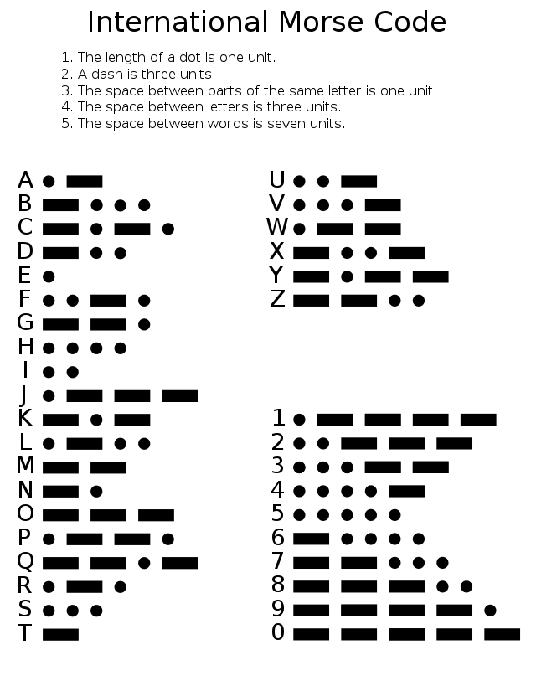Say, for example, we can send A using the following pattern “DOT DASH”. And B using “DASH DOT DOT DOT”. And the patterns for the various letters of Alphabet are given here,

Figure. International Morse Code List

Here, we basically created 2 separate delay sub-routine for the DOT and DASH. And then, according to our need, we generated light and sound using LED Relay and Buzzer. Our implementation scope was only for A and B. We didn’t continue to do for the rest, because our goal was to show the implementation for any letter. And we did 2 of them, to show that we can send A and B in any order we want but still we would be able to achieve that, up and until we press ‘0’ to go into the **EXIT mode**.

**Code**

;;;;;;;;;;;;;;;;;;;;;;;;;;;;;;;;;;;;;;;;;;;;;;;;;;;;;

CHECKNEXT_RE:

CJNE A,#'M', CHECKN_M

CLR RI

GO_M:

CLR RI

REP4: JNB RI,REP4

SJMP GO5

CHECKN_M: LJMP CHECKNEXT_M

GO5:

MOV A,SBUF

CJNE A,#'0',JA_M

LJMP CONT_M

JA_M:

CJNE A,#'A',M_B

CLR P3.5

CLR P3.6

ACALL DOT

SETB P3.5

SETB P3.6

ACALL DELAY_RE

CLR P3.5

CLR P3.6

ACALL DASH

ACALL DASH

SETB P3.5

SETB P3.6

ACALL DELAY

CLR RI

LJMP GO_M

M_B:

CJNE A,#'B',GO_M

CLR P3.5

CLR P3.6

ACALL DASH

SETB P3.5

SETB P3.6

ACALL DELAY_RE

CLR P3.5

CLR P3.6

ACALL DOT

SETB P3.5

SETB P3.6

ACALL DELAY_RE

CLR P3.5

CLR P3.6

ACALL DOT

SETB P3.5

SETB P3.6

ACALL DELAY

CLR RI

LJMP GO_M

# LED Matrix

An LED dot matrix display consists of a matrix of LED’s arranged in a rectangular configuration. An 8×8 matrix consists of 64 dots or pixels. There is a LED for each pixel and these LEDs are connected to total of 16 pins. It can be used to display almost anything by switching ON /OFF a desired configuration of LED’s. You can identify the pin out and circuit diagram of it using the following figure.  
The dot matrix display has 64 LEDs and evenly grouped into 8 columns and 8 rows. Any individual LED or a group of LEDs in the matrix can be activated by switching the required number of rows and columns. For example, in the above figure if Row1 is made high and Column1 is made low, the top left LED (address R1C1) will glow.

## Working Procedure

R1-R8 🡪 Row Initialisation (Active High)

C1-C8 🡪 Column Initialisation (Active Low)

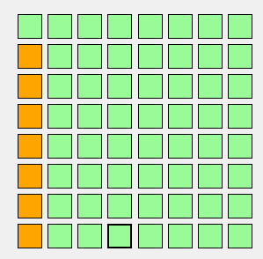

|  |  |  |  |  |  |  |  |
| --- | --- | --- | --- | --- | --- | --- | --- |
| R1 | R2 | R3 | R4 | R5 | R6 | R7 | R8 |
| 0 | 1 | 1 | 1 | 1 | 1 | 1 | 0 |
| C1 | C2 | C3 | C4 | C5 | C6 | C7 | C8 |
| 0 | 1 | 1 | 1 | 1 | 1 | 1 | 1 |

|  |  |  |  |  |  |  |  |
| --- | --- | --- | --- | --- | --- | --- | --- |
| R1 | R2 | R3 | R4 | R5 | R6 | R7 | R8 |
| 0 | 0 | 0 | 1 | 0 | 0 | 0 | 1 |
| C1 | C2 | C3 | C4 | C5 | C6 | C7 | C8 |
| 1 | 0 | 1 | 1 | 1 | 1 | 1 | 1 |

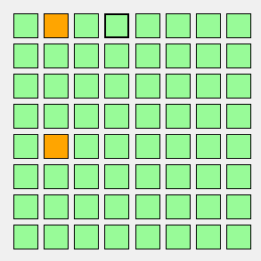

|  |  |  |  |  |  |  |  |
| --- | --- | --- | --- | --- | --- | --- | --- |
| R1 | R2 | R3 | R4 | R5 | R6 | R7 | R8 |
| 0 | 0 | 0 | 1 | 0 | 0 | 0 | 1 |
| C1 | C2 | C3 | C4 | C5 | C6 | C7 | C8 |
| 1 | 1 | 0 | 1 | 1 | 1 | 1 | 1 |

|  |  |  |  |  |  |  |  |
| --- | --- | --- | --- | --- | --- | --- | --- |
| R1 | R2 | R3 | R4 | R5 | R6 | R7 | R8 |
| 0 | 0 | 0 | 1 | 0 | 0 | 0 | 1 |
| C1 | C2 | C3 | C4 | C5 | C6 | C7 | C8 |
| 1 | 1 | 1 | 0 | 1 | 1 | 1 | 1 |

|  |  |  |  |  |  |  |  |
| --- | --- | --- | --- | --- | --- | --- | --- |
| R1 | R2 | R3 | R4 | R5 | R6 | R7 | R8 |
| 0 | 0 | 0 | 1 | 0 | 0 | 0 | 1 |
| C1 | C2 | C3 | C4 | C5 | C6 | C7 | C8 |
| 1 | 1 | 1 | 0 | 1 | 1 | 1 | 1 |

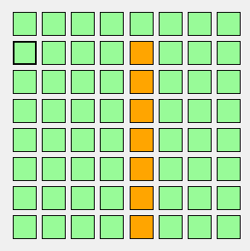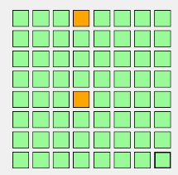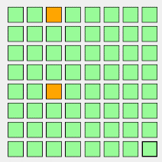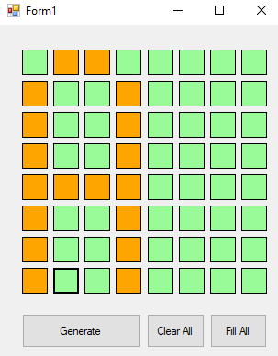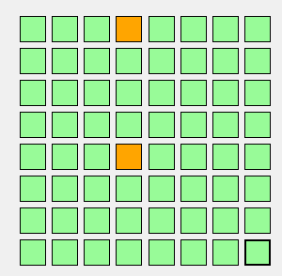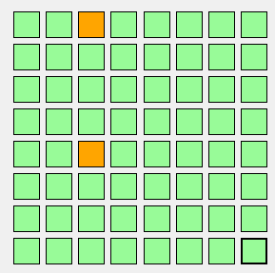

=

+

+

+

+

**Code**

CJNE A,#'X',CHECKN_PRE

CLR RI

GO_PRE:

CLR RI

MOV P2,#00000000B

MOV P1,#00000000B

REP14: JNB RI,REP14

SJMP GO15

CHECKN_PRE: LJMP CHECKNEXT_PRE

GO15:

MOV A,SBUF

CJNE A,#'0',JA_PRE

MOV P2,#11111111B

MOV P1,#11111111B

LJMP CONT_PRE

JA_PRE:

CJNE A,#'A',LED_B

MOV R1,#1

LED_LOOP2: MOV R2,#2

LED_LOOP1: MOV R3,#255

LED_LOOP:

CLR RI

MOV P1,#01111110B

MOV P2,#11111110B

ACALL DELAY_LED

MOV P1,#10001000B

MOV P2,#11111101B

ACALL DELAY_LED

MOV P1,#10001000B

MOV P2,#11111011B

ACALL DELAY_LED

MOV P1,#10001000B

MOV P2,#11110111B

ACALL DELAY_LED

MOV P1,#01111110B

MOV P2,#11101111B

ACALL DELAY_LED

DJNZ R3,LED_LOOP

DJNZ R2,LED_LOOP1

DJNZ R1,LED_LOOP2

LJMP GO_PRE

LJMP GO_PRE

LED_B:

CJNE A,#'B',GO_PRE

MOV R1,#1

LED_LOOPB2: MOV R2,#3

LED_LOOPB1: MOV R3,#255

LED_LOOPB:

MOV P1,#11111111B

MOV P2,#11111110B

ACALL DELAY_LED

MOV P1,#10001001B

MOV P2,#11111101B

ACALL DELAY_LED

MOV P1,#10001001B

MOV P2,#11111011B

ACALL DELAY_LED

MOV P1,#01100110B

MOV P2,#11110111B

ACALL DELAY_LED

DJNZ R3,LED_LOOPB

DJNZ R2,LED_LOOPB1

DJNZ R1,LED_LOOPB2

## Demonstration

1. 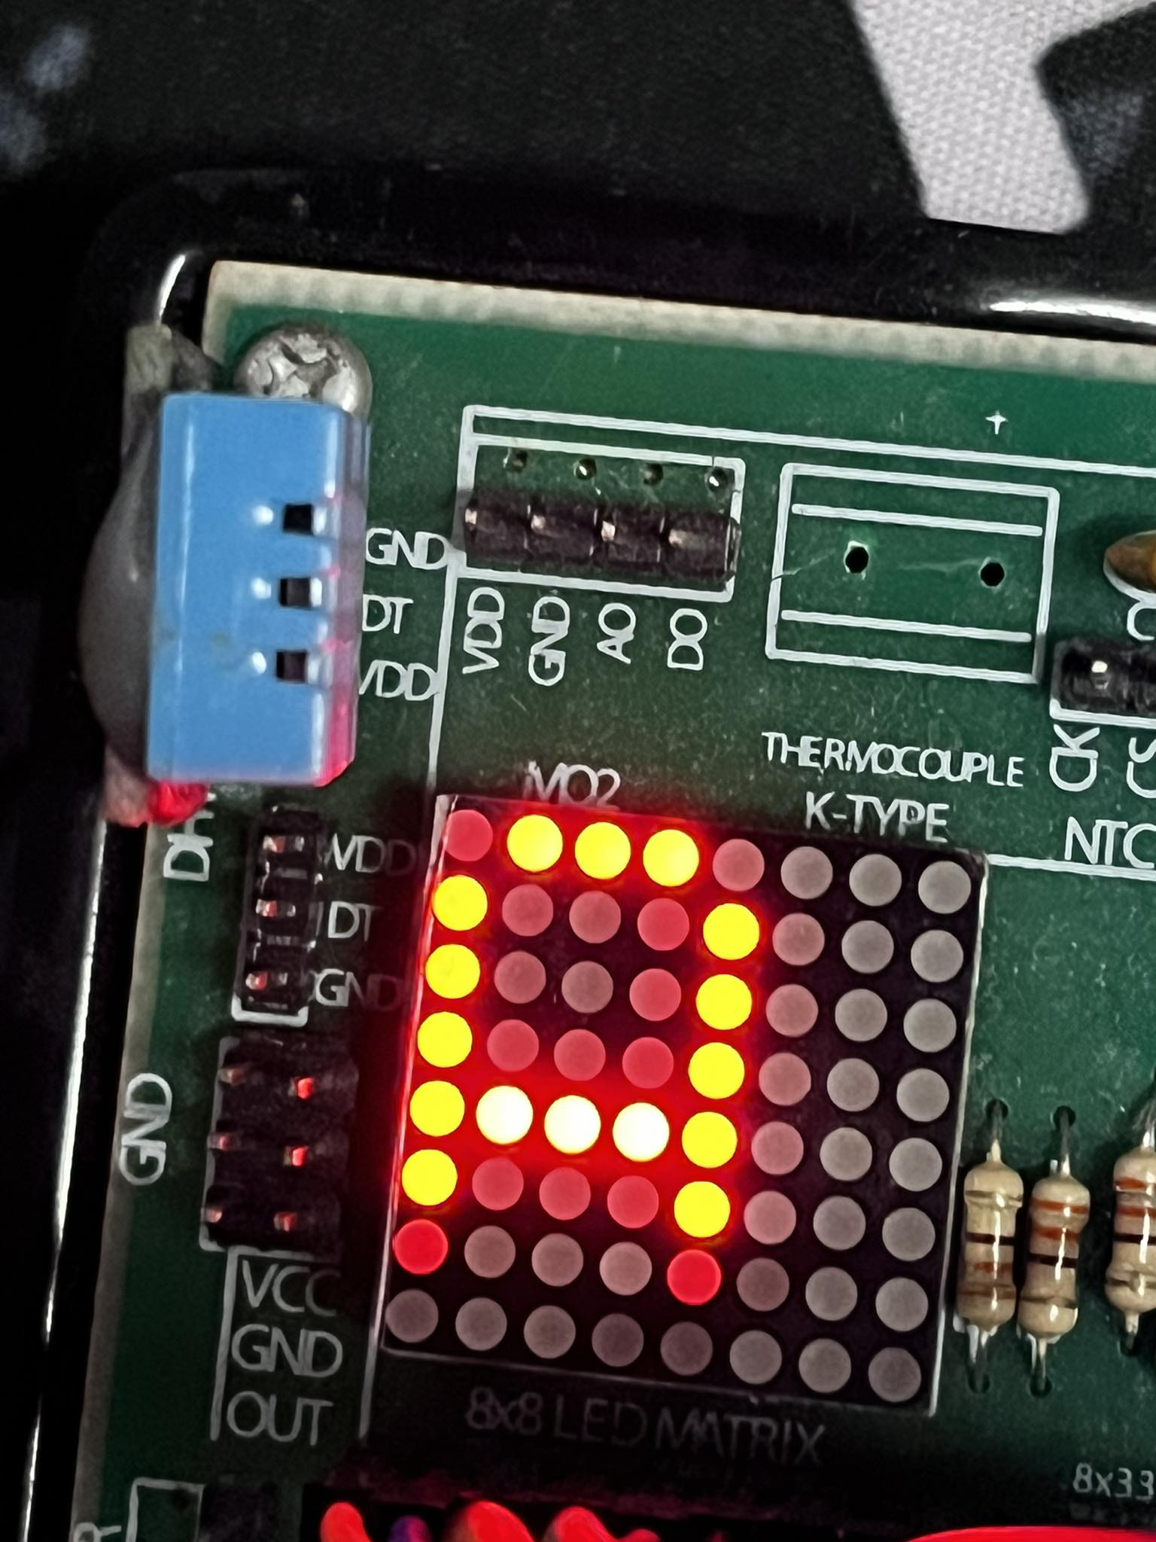Display of ‘A’
2. 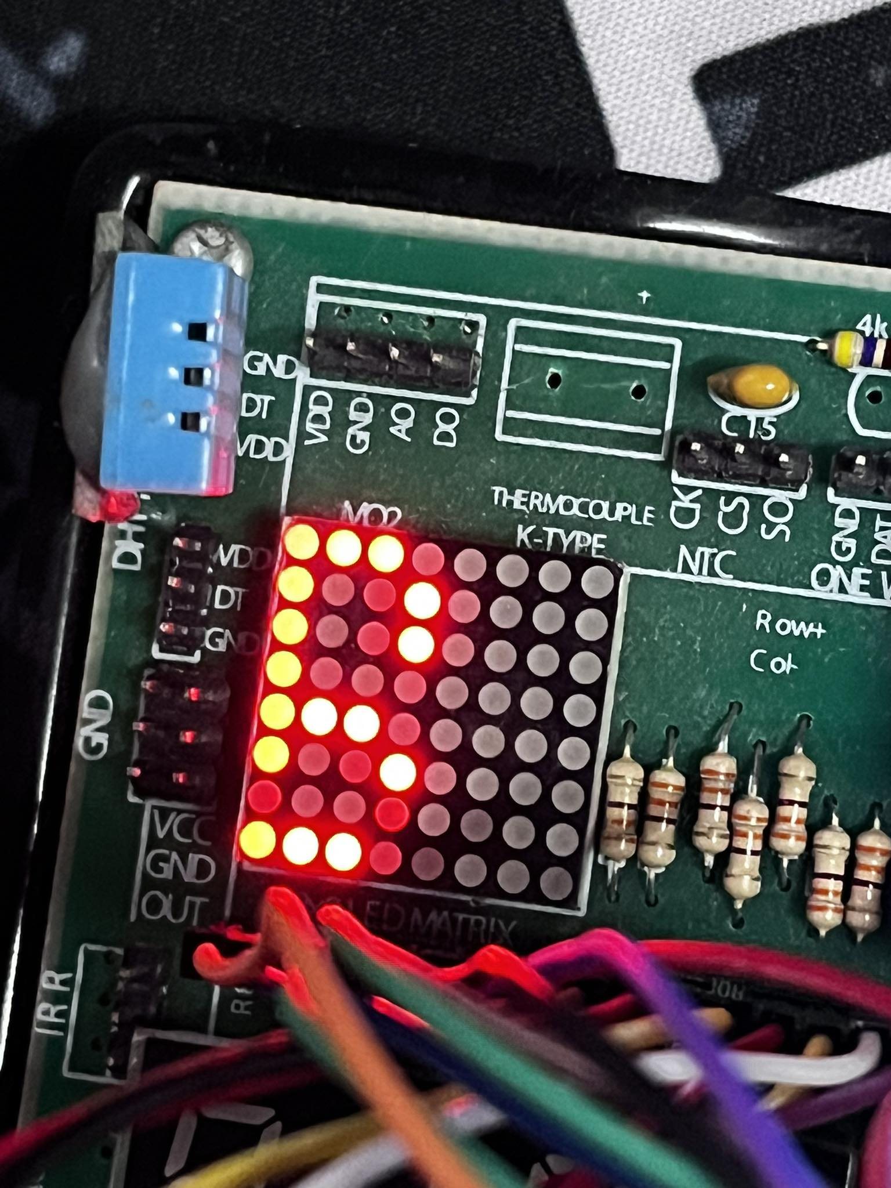Display of ‘B’

# Encryption

The encryption mode, activated by pressing 'D', transformed incoming messages by shifting their ASCII values by a decimal factor of 7. This shift entailed a cryptographic transformation, effectively encoding the transmitted information. For instance, a character 'A' (ASCII value 65) would be shifted by 7 positions, becoming 'H' (ASCII value 72). This method of encryption added a layer of security to the exchanged data, ensuring confidentiality and demonstrating a rudimentary yet functional cryptographic technique within the Bluetooth-8051 interface.

**Code**

CJNE A,#'D',CHECKN2

CLR RI ; register involved in receiving data from bluetooth and ensuring it

REP1: JNB RI, REP1

SJMP GO2

CHECKN2: LJMP CHECKNEXT2

GO2:

GOGO:

REP2: JNB RI, REP2

; preparing LCD

MOV A,#38H ; creatiing 2 lines and 5*7 matrix

ACALL COMNWRT

ACALL DELAY

MOV A,#0EH ; display on, cursor blinking

ACALL COMNWRT

ACALL DELAY

MOV A,#01H ; clear display skin

ACALL COMNWRT

ACALL DELAY

MOV A,#06H ; cursor shift right

ACALL COMNWRT

ACALL DELAY

MOV A,#0CH ; display on, cursor off

ACALL COMNWRT

ACALL DELAY

; writing the data from bluetooth

MOV A,SBUF ; data from bluetooth stored in SBUF

ADD A,#07H

CJNE A,#'7',JAWAD

LJMP CONT1

JAWAD:

ACALL DATAWRT ; takes data from app and prints it in LCD

ACALL DELAY

ACALL DELAY

ACALL DELAY

ACALL DELAY

ACALL DELAY

ACALL DELAY

ACALL DELAY

ACALL DELAY

CLR RI ; register involved in receiving data from bluetooth and ensuring it

LJMP GOGO; to the start mode

## No description available.Demonstration

# LED Relay Control

The relay, an electrically operated switch, facilitated electrical isolation, ensuring safe and controlled operations. Through specific commands sent via Bluetooth, the microcontroller triggered the relay to either complete or interrupt the circuit, thus turning the LED on or off.

In this specific feature, after activating the LED relay control mode (triggered by the character '1'), the subsequent digit sent via Bluetooth determined the duration for which the relay controlled the LED. For instance, upon receiving '1' followed by '5' via Bluetooth, the microcontroller interpreted this sequence as an instruction to toggle the LED relay on and off five times consecutively, with each on-off cycle lasting for a predefined duration.

**Code**

CJNE A,#'1', CHECKN_RE

CLR RI

GO_RE:

REP3: JNB RI,REP3

SJMP GO4

CHECKN_RE: LJMP CHECKNEXT_RE

GO4:

MOV A,SBUF

CJNE A,#'0',JA_RE

LJMP CONT_RE

JA_RE:

ANL A, 0FH

MOV R2,A

RE_LOOP:

CLR P3.6

ACALL DELAY_RE

ACALL DELAY_RE

SETB P3.6

ACALL DELAY_RE

ACALL DELAY_RE

DJNZ R2, RE_LOOP

CLR RI

*Demonstration of this part has to be shown via video or live demonstration.*

# EXIT Mode

By transmitting the character '0' over Bluetooth, the exit mode is activated, functioning as a global command to restore the system to its original or initial condition. When the 8051 microcontroller receives the value '0', it interprets this as a directive to stop any modes or operations that were previously initiated.

This function efficiently ended all existing activities, restoring the system to its original configuration, prepared to accept new instructions and function based on the default settings. The exit mode serves as a regulatory mechanism to cease current operations, facilitating a seamless transition to a neutral state and allowing the user to reset or terminate any active modes initiated by previous instructions.

# Complete Hardware Setup

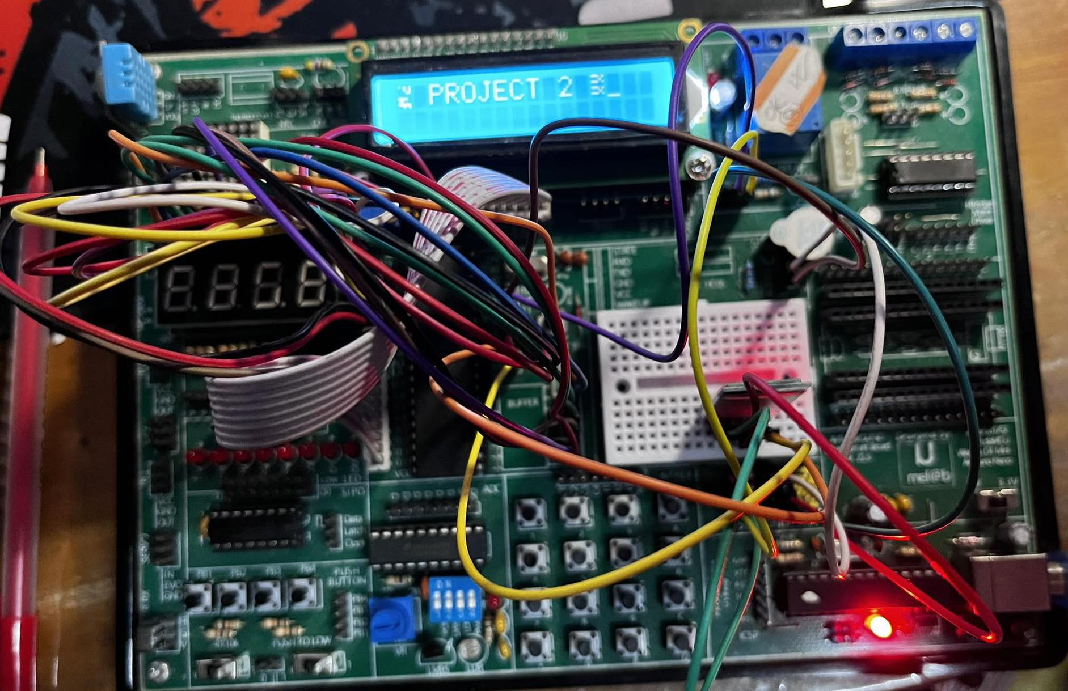

# Problems Faced

* + 1. We were unable to produce an LED matrix lookup table and thus, we were limited to the letters ‘A’ and ‘B’ respectively.
    2. We were unable to produce an Morse Code lookup table and thus, we were limited to the letters ‘A’ and ‘B’ respectively.
    3. A further and more thorough encryption could’ve been done and it is a work in progress for future development
    4. ADC Implementation was halted due to the damaged LM35 sensor on the development board. However, the LDR sensor was able to be converted to a digital value in a separate file, although not integrated within the scope of this project.
    5. The display and input from the Bluetooth could’ve been arranged in a more formal manner.

# Final Discussion

In conclusion, the successful integration of Bluetooth technology with the 8051 Microcontroller yielded a multifaceted system capable of diverse real-time operations triggered by specific characters sent via a Serial Bluetooth Android app.

The project showcased the adaptability and versatility of the 8051 microcontroller in interpreting Bluetooth-transmitted commands to enact various functionalities. From controlling countdowns, LEDs, buzzers, and relays to implementing encryption, Morse code transmission, and display functions, each feature demonstrated the microcontroller's ability to interact with external components and execute complex actions in response to wireless commands. In the end, we want to conclude with the spirit of debugging unforgivable typing errors at the cost of wasting 3 days.

# Complete Code

ORG 00H

CLR P2.5 ; LED connected

SETB P2.4 ; as buzzer connected

; for Bluetooth module

MOV TMOD,#20H ; timer 1 mode 2 is selected

MOV TH1,#0FDH ; baud rate

MOV SCON,#50H ; serial mode 1 10 bit total isn, 8db, 1STOPb

CLR TI ; making TI reg zero

SETB TR1 ; starting timer 1

;------------DISPLAY INITIALIZATION----------

MOV DPTR,#MYLCD ;DPTR stores the LCD initialization sequence

CIU1: CLR A

MOVC A,@A+DPTR

LCALL COMNWRT

LCALL DELAY

JZ SIU1 ;Runs the rest of the code

INC DPTR

SJMP CIU1

SIU1: MOV DPTR,#MSG1

DIU1: CLR A

MOVC A,@A+DPTR

LCALL DATAWRT

LCALL DOT

JZ SIU2 ;Runs rest of the code

INC DPTR

SJMP DIU1

SIU2: MOV A, #01 ;Clear LCD

ACALL COMNWRT ;Call command subroutine

ACALL DELAY ;Give LCD some time

LCALL DATAWRT

MOV DPTR,#MSG2

DIU2: CLR A

MOVC A,@A+DPTR

LCALL DATAWRT

LCALL DOT

JZ CONT1 ;Runs rest of the code

INC DPTR

SJMP DIU2

CONT1:

GOBACK:

CONT_RE:

CONT_M:

CONT_PRE:

CLR RI ; register involved in receiving data from bluetooth and ensuring it

REP: JNB RI, REP

; preparing LCD

MOV DPTR,#MYLCD2 ;DPTR stores the LCD initialization sequence

CIIU1: CLR A

MOVC A,@A+DPTR

LCALL COMNWRT

LCALL DELAY

JZ SIIU1 ;Runs the rest of the code

INC DPTR

SJMP CIIU1

; writing the data from bluetooth

SIIU1:

MOV A,SBUF ; data from bluetooth stored in SBUF

ACALL DATAWRT ; takes data from app and prints it in LCD

ACALL DELAY

CJNE A,#'X',CHECKN_PRE

CLR RI

GO_PRE:

CLR RI

MOV P2,#00000000B

MOV P1,#00000000B

REP14: JNB RI,REP14

SJMP GO15

CHECKN_PRE: LJMP CHECKNEXT_PRE

GO15:

MOV A,SBUF

CJNE A,#'0',JA_PRE

MOV P2,#11111111B

MOV P1,#11111111B

LJMP CONT_PRE

JA_PRE:

CJNE A,#'A',LED_B

MOV R1,#1

LED_LOOP2: MOV R2,#2

LED_LOOP1: MOV R3,#255

LED_LOOP:

CLR RI

MOV P1,#01111110B

MOV P2,#11111110B

ACALL DELAY_LED

MOV P1,#10001000B

MOV P2,#11111101B

ACALL DELAY_LED

MOV P1,#10001000B

MOV P2,#11111011B

ACALL DELAY_LED

MOV P1,#10001000B

MOV P2,#11110111B

ACALL DELAY_LED

MOV P1,#01111110B

MOV P2,#11101111B

ACALL DELAY_LED

DJNZ R3,LED_LOOP

DJNZ R2,LED_LOOP1

DJNZ R1,LED_LOOP2

LJMP GO_PRE

LJMP GO_PRE

LED_B:

CJNE A,#'B',GO_PRE

MOV R1,#1

LED_LOOPB2: MOV R2,#3

LED_LOOPB1: MOV R3,#255

LED_LOOPB:

MOV P1,#11111111B

MOV P2,#11111110B

ACALL DELAY_LED

MOV P1,#10001001B

MOV P2,#11111101B

ACALL DELAY_LED

MOV P1,#10001001B

MOV P2,#11111011B

ACALL DELAY_LED

MOV P1,#01100110B

MOV P2,#11110111B

ACALL DELAY_LED

DJNZ R3,LED_LOOPB

DJNZ R2,LED_LOOPB1

DJNZ R1,LED_LOOPB2

LJMP GO_PRE

CHECKNEXT_PRE:

CJNE A,#'y',CHEKK

CLR P3.5

CHEKK:

CJNE A,#'n',CHEKK1

SETB P3.5

CHEKK1:

CJNE A,#'l', CHECKNEXT

SETB P3.6

CHECKNEXT:

CJNE A,#'L', CHECKNEXT1

CLR P3.6

;;;;;;;;;;;;;;;;;;;;;;;;;;;;;;;;;;;;;;;;;;;;;;;;;;;;;

CHECKNEXT1:

CJNE A,#'1', CHECKN_RE

CLR RI

GO_RE:

REP3: JNB RI,REP3

SJMP GO4

CHECKN_RE: LJMP CHECKNEXT_RE

GO4:

MOV A,SBUF

CJNE A,#'0',JA_RE

LJMP CONT_RE

JA_RE:

ANL A, 0FH

MOV R2,A

RE_LOOP:

CLR P3.6

ACALL DELAY_RE

ACALL DELAY_RE

SETB P3.6

ACALL DELAY_RE

ACALL DELAY_RE

DJNZ R2, RE_LOOP

CLR RI

LJMP GO_RE

;;;;;;;;;;;;;;;;;;;;;;;;;;;;;;;;;;;;;;;;;;;;;;;;;;;;;

CHECKNEXT_RE:

CJNE A,#'M', CHECKN_M

CLR RI

GO_M:

CLR RI

REP4: JNB RI,REP4

SJMP GO5

CHECKN_M: LJMP CHECKNEXT_M

GO5:

MOV A,SBUF

CJNE A,#'0',JA_M

LJMP CONT_M

JA_M:

CJNE A,#'A',M_B

CLR P3.5

CLR P3.6

ACALL DOT

SETB P3.5

SETB P3.6

ACALL DELAY_RE

CLR P3.5

CLR P3.6

ACALL DASH

ACALL DASH

SETB P3.5

SETB P3.6

ACALL DELAY

CLR RI

LJMP GO_M

M_B:

CJNE A,#'B',GO_M

CLR P3.5

CLR P3.6

ACALL DASH

SETB P3.5

SETB P3.6

ACALL DELAY_RE

CLR P3.5

CLR P3.6

ACALL DOT

SETB P3.5

SETB P3.6

ACALL DELAY_RE

CLR P3.5

CLR P3.6

ACALL DOT

SETB P3.5

SETB P3.6

ACALL DELAY

CLR RI

LJMP GO_M

;;;;;;;;;;;;;;;;;;;;;;;;;;;;;;;;;;;;;;;;;;;;;;;;;;;;;

CHECKNEXT_M:

CJNE A,#'D',CHECKN2

CLR RI ; register involved in receiving data from bluetooth and ensuring it

REP1: JNB RI, REP1

SJMP GO2

CHECKN2: LJMP CHECKNEXT2

GO2:

GOGO:

REP2: JNB RI, REP2

; preparing LCD

MOV A,#38H ; creatiing 2 lines and 5*7 matrix

ACALL COMNWRT

ACALL DELAY

MOV A,#0EH ; display on, cursor blinking

ACALL COMNWRT

ACALL DELAY

MOV A,#01H ; clear display skin

ACALL COMNWRT

ACALL DELAY

MOV A,#06H ; cursor shift right

ACALL COMNWRT

ACALL DELAY

MOV A,#0CH ; display on, cursor off

ACALL COMNWRT

ACALL DELAY

; writing the data from bluetooth

MOV A,SBUF ; data from bluetooth stored in SBUF

ADD A,#07H

CJNE A,#'7',JAWAD

LJMP CONT1

JAWAD:

ACALL DATAWRT ; takes data from app and prints it in LCD

ACALL DELAY

ACALL DELAY

ACALL DELAY

ACALL DELAY

ACALL DELAY

ACALL DELAY

ACALL DELAY

ACALL DELAY

CLR RI ; register involved in receiving data from bluetooth and ensuring it

LJMP GOGO

CHECKNEXT2:

CJNE A,#'C', GOBACK1

LJMP GO3

GOBACK1: LJMP GOBACK

GO3:

MOV R1, #9

MOV R2, #39H

COUNT_LOOP:

ACALL DELAY

ACALL DELAY

ACALL DELAY

ACALL DELAY

ACALL DELAY

MOV A,#38H

ACALL COMNWRT

ACALL DELAY

MOV A,#0EH

ACALL COMNWRT

ACALL DELAY

MOV A,#01H

ACALL COMNWRT

ACALL DELAY

MOV A,#06H

ACALL COMNWRT

ACALL DELAY

MOV A,#0CH

ACALL COMNWRT

ACALL DELAY

MOV A,R2

DEC R2

ACALL DATAWRT

ACALL DELAY

DJNZ R1, COUNT_LOOP

CLR P3.5 ; Buzzer on

ACALL DELAY1

SETB P3.5 ; after a certain time, turn it off

ACALL GOBACK

AGAIN: SJMP AGAIN

; for reading and writing in LCD subroutine and delay subroutine

COMNWRT: ; for command writing

MOV P0,A

CLR P3.2 ; RS=0

CLR P3.3 ; RW=0

SETB P3.4 ; EN=1

ACALL DELAY

CLR P3.4 ; EN=0 (high to low operation)

RET

DATAWRT: ; for data writing

MOV P0,A

SETB P3.2 ; RS=1

CLR P3.3 ; RW=0

SETB P3.4 ; EN=1

ACALL DELAY

CLR P3.4 ; EN=0(high to low)

RET

DATAENC:

ANL A, #07H

MOV P0,A

SETB P3.2 ; RS=1

CLR P3.3 ; RW=0

SETB P3.4 ; EN=1

ACALL DELAY

CLR P3.4 ; EN=0(high to low)

RET

; Delay subroutines

DELAY:

MOV R3,#50

HERE2: MOV R4,#255

HERE: DJNZ R4, HERE

DJNZ R3,HERE2

RET

DOT:

MOV R2,#10

HERR_D1: MOV R5,#50

HERR_D2: MOV R6,#255

HERR_D3: DJNZ R6,HERR_D3

DJNZ R5,HERR_D2

DJNZ R2,HERR_D1

RET

DASH:

MOV R2,#20

HERR_DD1: MOV R5,#50

HERR_DD2: MOV R6,#255

HERR_DD3: DJNZ R6,HERR_DD3

DJNZ R5,HERR_DD2

DJNZ R2,HERR_DD1

RET

;for buzzer alarm

DELAY1:

MOV R2,#50

HERR1: MOV R5,#50

HERR2: MOV R6,#255

HERR3: DJNZ R6,HERR3

DJNZ R5,HERR2

DJNZ R2,HERR1

RET

DELAY_RE:

MOV R3,#255

HERRR2: MOV R4,#255

HERRRE: DJNZ R4, HERRRE

DJNZ R3,HERRR2

RET

DELAY_PRE:

MOV R2,#100

HERR1_PRE: MOV R5,#255

HERR2_PRE: MOV R6,#255

HERR3_PRE: DJNZ R6,HERR3_PRE

DJNZ R5,HERR2_PRE

DJNZ R2,HERR1_PRE

RET

DELAY_LED:

MOV R6,#255D ; 1ms delay subroutine

HERE_LED: DJNZ R6,HERE_LED

RET

ORG 300H

MSG1: DB " GROUP 2 ",0

MSG2: DB " PROJECT 2 ",0

MYLCD : DB 38H,0EH,01,06,80H,0

MYLCD2 : DB 38H,0EH,01,06,0CH,0

END